Forecasting Indonesian Coal Sector Stock Prices Using a Hybrid ARIMA-LSTM Framework

Dayinta Agustina Zanuel¹, Ibrahim Frosly Alesandro², Fanya Az-Zahra Fakhressy³, Dinda Tria Kusuma⁴, Faiz Makiinun Amin⁵, Ulfa Siti Nuraini^{6*}

^{1,2,3,4,5,6} Data Science Departement, Faculty of Mathematics and Natural Sciences, Universitas Negeri Surabaya, Surabaya, Indonesia
*Corresponding author: ulfanuraini@unesa.ac.id

Received: -  Revised: -  Accepted: -  Published: -  Corresponding Author:  Author Name*: Ulfa Siti Nuraini  Email*: ulfanuraini@unesa.ac.id  DOI:  To be assigned  © 2026 Journal of Information Systems and Informatics. This open access article is distributed under a CC-BY License. | Abstract. Coal-sector stock prices exhibit high volatility and complex temporal patterns, requiring forecasting methods capable of capturing linear and nonlinear behaviors. This study develops a hybrid Autoregressive Integrated Moving Average-Long Short-Term Memory (ARIMA-LSTM) framework for forecasting the daily adjusted closing prices of ADRO, PTBA, INDY, and ITMG using Yahoo Finance data through December 2024. The proposed framework combines ARIMA for linear patterns and LSTM for nonlinear residual learning and is compared with standalone ARIMA and LSTM models using out-of-sample evaluation for January 2023–December 2024 based on MAE, RMSE, MAPE, and R². The hybrid model showed different performance across stocks, achieving MAPE values of 5.29% for PTBA, 8.51% for ITMG, 11.97% for ADRO, and 29.94% for INDY. The hybrid model yielded positive R² values for ADRO and PTBA, while negative R² values for ITMG and INDY indicate that hybridization did not consistently improve performance. The company-specific hybrid models were used to generate exploratory projections for 2025–2045, which represent methodological scenarios rather than investment recommendations. The study contributes a stock-specific evaluation of hybrid forecasting performance and provides a web-based analytical interface for monitoring coal-sector price scenarios.  Keywords: ARIMA-LSTM, coal stocks, financial forecasting, machine learning, decision-support systems, interactive dashboard
1. INTRODUCTION
Coal-sector stocks have attracted considerable attention in financial markets because their prices are closely associated with commodity cycles, market expectations, and changes in global energy conditions [1]. In Indonesia, coal companies represent an important segment of the stock market, and their performance is affected by fluctuations in coal prices, demand conditions, regulatory changes, and broader economic uncertainty [2]. These characteristics make coal-sector stocks a relevant case for studying financial time-series forecasting, particularly because price movements often exhibit high volatility and complex temporal patterns [3].

Financial forecasting remains challenging because stock prices exhibit both linear and nonlinear behaviors under changing market conditions [4]. Statistical models capture linear dependencies, whereas machine-learning approaches can learn complex nonlinear patterns, although careful configuration is required to avoid overfitting [5].

Recent studies have explored various machine-learning methods for stock-price prediction. A comparison of Support Vector Regression, Random Forest, and K-Nearest Neighbors for Indonesian stock-market prediction showed that Support Vector Regression achieved lower RMSE and MAE values because of its ability to model nonlinear relationships through suitable kernel functions, while other models showed reduced performance under rapid market changes [6]. However, single-model approaches may not fully capture the complex characteristics of financial data. Hybrid forecasting methods have therefore been introduced to integrate the strengths of different modelling approaches. In particular, hybrid statistical and deep-learning models combine the linear forecasting capability of statistical methods with the nonlinear pattern recognition ability of neural networks [7].

Although previous studies have reported improvements from hybrid forecasting models, several limitations remain [8]. Many existing studies primarily focus on overall prediction accuracy without examining whether model performance remains consistent across different stocks with distinct volatility characteristics [9]. Previous reviews have examined forecasting techniques, input variables, and prediction accuracy, but the integration of stock-specific evaluation, long-term exploratory projections, and an interactive analytical interface remains underexplored for Indonesian coal-sector stocks [10]. Since forecasting accuracy varies across markets and no consensus exists regarding a universally superior algorithm, hybrid-model effectiveness should be evaluated separately for each company [11].

The objective of this study is to develop and evaluate a hybrid Autoregressive Integrated Moving Average-Long Short-Term Memory (ARIMA-LSTM) framework for forecasting the stock prices of four Indonesian coal-sector companies: ADRO, PTBA, INDY, and ITMG. The hybrid model is compared with standalone ARIMA and LSTM models using out-of-sample evaluation metrics. The study also analyzes stock-specific performance, generates exploratory long-term projections for 2025–2045, and presents the results through a web-based analytical dashboard. Its main contribution is showing that hybrid forecasting performance varies across individual stocks and should be assessed through systematic model comparison rather than assumed to be universally superior.

2. METHODS
2.1. Research Framework
This study applies a structured forecasting and information-system workflow. Daily adjusted closing-price data are acquired and checked for missing or duplicate observations before being divided chronologically into training and testing periods. The complete pipeline is then executed independently for ADRO, PTBA, INDY, and ITMG. Standalone ARIMA was developed as the linear baseline following the Box-Jenkins framework [12] , while standalone LSTM was used as the nonlinear baseline. The hybrid ARIMA-LSTM model combines both approaches by training LSTM on ARIMA residuals, where the predicted residual is added to the ARIMA forecast [13]. The resulting forecasts are evaluated using MAE, RMSE, MAPE, and R², after which the company-specific hybrid ARIMA-LSTM models generate exploratory monthly projections for 2025–2045 that are presented through a web-based interactive dashboard [14].
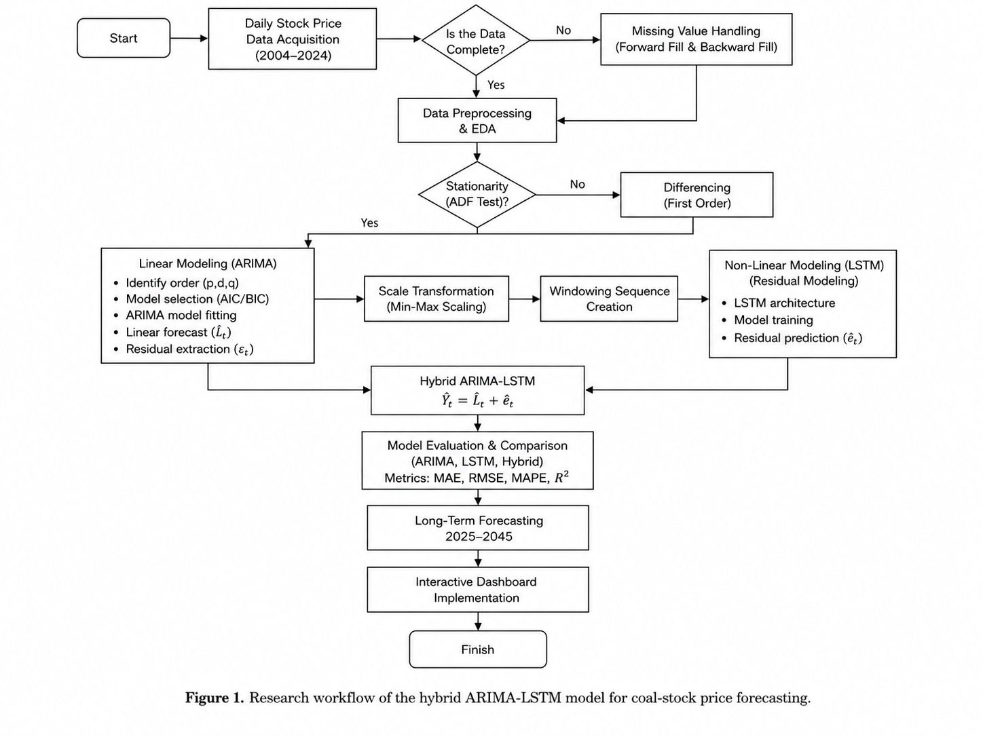
Figure 1. Research workflow of the hybrid ARIMA-LSTM model for coal-stock price forecasting.

2.2. Research Data and Dataset Split
The data used in this study consist of daily adjusted closing prices obtained from Yahoo Finance historical market data using the Python library yfinance. The dataset includes four Indonesian coal-sector stocks listed on the Indonesia Stock Exchange (IDX), namely ADRO (ADRO.JK), PTBA (PTBA.JK), INDY (INDY.JK), and ITMG (ITMG.JK). The dataset consists of daily trading observations (business days) from January 2004 to December 2024. Yahoo Finance provides several attributes, including Open, High, Low, Close, Adjusted Close, and Volume. Among these attributes, only the Adjusted Closing Price (Adj Close) was used as the forecasting input. The use of adjusted closing prices provides a more consistent historical series because it accounts for corporate actions such as stock splits and dividend adjustments. This variable is commonly used in univariate financial time-series forecasting because it allows models to focus on temporal patterns from historical price movements. Furthermore, using a single input variable ensures that ARIMA, LSTM, and hybrid ARIMA-LSTM models are evaluated under the same input conditions.

The collected dataset contains daily stock-price observations with the variables Date, ADRO, PTBA, INDY, and ITMG, while daily return variables were calculated to analyze price changes. The exact observation periods used in this study were July 16, 2008–December 30, 2024 for ADRO; January 2, 2004–December 30, 2024 for PTBA; June 11, 2008–December 30, 2024 for INDY; and December 18, 2007–December 30, 2024 for ITMG. The different starting dates occur because each stock has different historical data availability in Yahoo Finance.

However, this approach does not include external factors such as coal commodity prices, exchange rates, macroeconomic indicators, trading volume, or company fundamentals, which may also influence stock-price fluctuations [15]. This univariate approach was selected to evaluate the intrinsic predictive capability of historical price patterns before incorporating additional external variables in future multivariate forecasting frameworks.

The four companies were not combined into a single multivariate model; instead, each ticker was processed, trained, and evaluated independently using its own historical series. The dataset was divided using a chronological split with a calendar cutoff of December 31, 2022. Therefore, observations until December 30, 2022 were used as training data, while observations from January 2, 2023 to December 30, 2024 were used as testing data.

Furthermore, 15% of the training data were separated as validation data during LSTM training to monitor model performance and implement early stopping. This splitting strategy prevents future information leakage and ensures that evaluation is performed using unseen observations.
Table 1. Research dataset
Company | Ticker | Full observation period | Training period | Testing period
ADRO | ADRO.JK | 16 Jul. 2008-30 Dec. 2024 | 16 Jul. 2008-30 Dec. 2022 | 2 Jan. 2023-30 Dec. 2024
PTBA | PTBA.JK | 2 Jan. 2004-30 Dec. 2024 | 2 Jan. 2004-30 Dec. 2022 | 2 Jan. 2023-30 Dec. 2024
INDY | INDY.JK | 11 Jun. 2008-30 Dec. 2024 | 11 Jun. 2008-30 Dec. 2022 | 2 Jan. 2023-30 Dec. 2024
ITMG | ITMG.JK | 18 Dec. 2007-30 Dec. 2024 | 18 Dec. 2007-30 Dec. 2022 | 2 Jan. 2023-30 Dec. 2024

2.3. Data Preprocessing
Data preprocessing was performed independently for each stock to prepare the historical price series before ARIMA, LSTM, and hybrid ARIMA-LSTM modeling. The preprocessing procedure consisted of data quality checking, return calculation, stationarity testing, differencing, normalization, and sequence preparation.

First, the dataset was examined for missing values, duplicate records, and unusual values to ensure data consistency [16]. The observations were arranged chronologically based on trading dates [17]. Missing values, if present, were handled using forward fill and backward fill methods to maintain continuity in the time-series data. Daily return values were calculated from consecutive adjusted closing prices to analyze relative price changes; however, the forecasting models used adjusted closing prices as the main input variable.

For ARIMA modeling, stationarity testing was conducted using the Augmented Dickey-Fuller (ADF) test and confirmed using the Kwiatkowski-Phillips-Schmidt-Shin (KPSS) test. Since the stock-price series at level were identified as non-stationary, first-order differencing was applied to obtain a stationary series. The differencing process is defined as:
$$ΔP_{t}= P_{t}- P_{\left\{t-1\right\}}$$ | (1)

where $P_{t}$ represents the closing price at time t and $ΔP_{t}$ represents the differenced price series. Based on the stationarity testing results, the integration order used in ARIMA modeling was set to $d = 1$.

For the hybrid ARIMA-LSTM model, the residual values generated from the ARIMA forecasting process were used as input for the LSTM model [18]. The residual sequence was transformed using Min-Max scaling with a range of $(-1,1)$ to normalize the values into a consistent range. The scaling process was performed using training data and then applied to validation and testing data to prevent information leakage [19]. All preprocessing stages were conducted separately for ADRO, PTBA, INDY, and ITMG to preserve company-specific price characteristics and volatility patterns. The normalized residual data were converted into supervised learning sequences using a sliding-window approach [20]. A window size of 30 previous observations was used as input to predict the following residual value.

2.4. ARIMA Model Development
ARIMA was used to capture the linear component of each stock-price series. The ARIMA model is represented as $ARIMA\left(p,d,q\right)$, where $p$ represents the autoregressive order, $d$represents the differencing order, and $q$represents the moving-average order. The general formulation of ARIMA is expressed as:
$$ϕ_{p\left(B\right)\left(1-B\right)}^{d}P_{t}= c + θ_{q\left(B\right)ε_{t}}$$ | (2)

formulation is expressed in Equation (2), where $B$ denotes the backshift operator, $d$ is the differencing order, $ϕ_{p\left(B\right)}$ represents the autoregressive polynomial, $θ_{q\left(B\right)}$ represents the moving-average polynomial, $c$ is a constant, and $ϵ_{t}$ is the random error.

The ARIMA parameters were determined separately for each company because each stock has different historical price characteristics. The differencing order $(d)$ was determined based on the stationarity testing results described in the preprocessing stage. Since all stock-price series were identified as non-stationary at the original level, first-order differencing was applied, resulting in an integration order of $d = 1$.

The autoregressive order $\left(p\right)$ and moving-average order $(q)$ were selected using a candidate model evaluation procedure based on grid search and Akaike Information Criterion (AIC) [21]. Several combinations $p$ and $q$ were fitted using the training dataset, with both parameters evaluated within the range of 0 to 4. The model with the lowest AIC value was selected as the optimal ARIMA configuration because it provides a balance between model fit and complexity. The parameter selection process was conducted independently for ADRO, PTBA, INDY, and ITMG.

The selected configurations are summarized in Table 2.
Table 2. Selected ARIMA configurations for each company
Company | Ticker | Selected ARIMA order | Model role
ADRO | ADRO.JK | ARIMA(3,1,3) | Linear price forecast
PTBA | PTBA.JK | ARIMA(1,1,3) | Linear price forecast
INDY | INDY.JK | ARIMA(1,1,3) | Linear price forecast
ITMG | ITMG.JK | ARIMA(3,1,3) | Linear price forecast

The ARIMA-only output represents the linear forecast generated from the selected company-specific ARIMA model. The forecast values and residuals generated from the ARIMA were subsequently used in the hybrid ARIMA-LSTM stage, where LSTM was applied to learn nonlinear patterns from the residual component [22].

2.5. LSTM Model Development
Long Short-Term Memory (LSTM) was used to model nonlinear temporal patterns in stock-price movements. Unlike ARIMA, which captures linear dependencies in time-series data, LSTM is designed to learn sequential patterns through its memory mechanism [23]. In this study, LSTM was developed as a standalone forecasting model and was also used as the nonlinear component in the hybrid ARIMA-LSTM framework.

The standalone LSTM used adjusted closing-price sequences with a 30-day sliding window to predict the next value [24]. The architecture consisted of two LSTM layers followed by dropout and dense layers, while model training used the Adam optimizer, MSE loss, validation data, and early stopping. The LSTM hyperparameters were fixed and applied consistently across all four stocks to maintain model comparability. The validation subset was used to monitor training through early stopping and adaptive learning-rate reduction rather than for hyperparameter search. The forecasting framework was implemented in Python using yfinance for data acquisition, statistical and machine-learning libraries for preprocessing and modelling, and TensorFlow/Keras for LSTM training, with a fixed random seed of 2024 applied to support reproducibility.

The LSTM architecture and training configuration are summarized in Table 3.
Table 3. LSTM architecture and training configuration
Component | Configuration
Input window | 30 daily observations
First LSTM layer | 64 units; return sequences enabled
Dropout after first LSTM | 0.20
Second LSTM layer | 64 units
Dropout after second LSTM | 0.20
Dense layer | 32 units; ReLU activation
Output layer | 1 unit; linear output
Total trainable parameters | 52,033
Optimizer and learning rate | Adam; 0.001
Loss function | Mean Squared Error
Batch size and maximum epochs | 32; 100 epochs
Validation and early stopping | 15% validation split; patience = 15

2.6. LSTM and Hybrid ARIMA-LSTM Development
The hybrid ARIMA-LSTM model combines the linear forecasting capability of ARIMA with the nonlinear sequence learning capability of LSTM [25].

The residual component was calculated as:
$$e_{t}= P_{t}- P_{t}^{ARIMA}$$ | (3)

where${ P}_{t}$ represents the observed stock price at time $t$, and $P_{t}^{ARIMA}$ represents the ARIMA forecast. The residuals were normalized and transformed into 30-day input sequences, while LSTM estimated the nonlinear residual correction [26].

The final hybrid forecast was obtained as:
$$P_{t}^{Hybrid}=P_{t}^{ARIMA}+ e_{t}^{LSTM}$$ | (4)

where $P_{t}^{Hybrid}$ represents the final hybrid prediction and $e_{t}^{LSTM}$ represents the nonlinear correction estimated by LSTM. The model was developed independently for ADRO, PTBA, INDY, and ITMG using the same chronological data split.

Standalone ARIMA and LSTM models were also evaluated as baseline comparisons using the same dataset division and evaluation procedure to assess whether hybridization improved forecasting performance.

2.7. Model Evaluation and Performance Measurement
Model performance was evaluated on the testing period by comparing the forecasting results of ARIMA, LSTM, and hybrid ARIMA-LSTM models using three error-based evaluation metrics: Mean Absolute Error (MAE), Root Mean Squared Error (RMSE), and Mean Absolute Percentage Error (MAPE). These metrics were selected because they provide complementary measures of forecasting accuracy across different error characteristics.

MAE measures the average absolute difference between the predicted and observed prices, while RMSE assigns a higher penalty to larger forecasting errors. MAPE expresses the prediction error in percentage terms, allowing proportional comparison across stocks with different price scales. Lower values of MAE, RMSE, and MAPE indicate better forecasting performance.

The evaluation metrics are defined as follows:
$$MAE = \left(\frac{1}{n}\right)\sum_{t=1}^{n}{\left|y_{t}-y_{t}\right|}$$ | (5)
$$RMSE = \sqrt{\left(\frac{1}{n}\right)\sum_{t=1}^{n}{{\left(y_{t}-y_{t}\right)}^{2}}}$$ | (6)
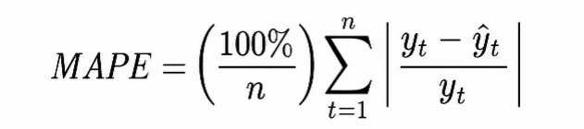 | (7)
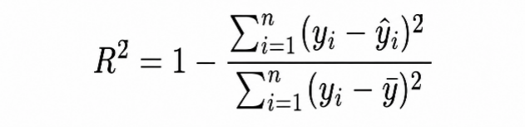 | (8)

where $y_{t}$ represents the observed stock price, ${\hat{y}}_{t}$represents the predicted value, and $n$ represents the number of observations in the testing period.

The evaluation was conducted separately for ADRO, PTBA, INDY, and ITMG. The forecasting accuracy of each model was then compared using a performance comparison table containing the MAE, RMSE, and MAPE values for ARIMA, LSTM, and hybrid ARIMA-LSTM models. The primary evaluation used a chronological holdout strategy because financial time-series forecasting requires preserving temporal order between training and testing data. The selected approach evaluates model performance on unseen observations while preventing future information leakage [27]. To assess robustness beyond the final holdout period, an expanding-window validation strategy was additionally applied using three pre-test evaluation windows. The models were trained using observations available up to the end of 2019, 2020, and 2021 and were subsequently evaluated on 2020, 2021, and 2022, respectively. All preprocessing and model estimation procedures were repeated independently within each fold to prevent future information leakage, while the January 2023–December 2024 period remained untouched for the final out-of-sample evaluation.

For the 2025–2045 exploratory projections, the ARIMA component was re-estimated using the full available price series through December 2024. Forecasts and 95% confidence intervals were generated using the SARIMAX get_forecast() and conf_int(alpha=0.05) procedures, respectively. These confidence bounds represent uncertainty associated with the ARIMA component and are used as an uncertainty envelope for the hybrid projections; they do not incorporate additional uncertainty from the LSTM residual correction.

3. RESULTS AND DISCUSSION
3.1. Results
3.1.1. Data Characteristics and Stationarity

Descriptive Statistics
Daily adjusted closing-price data for four Indonesian coal-sector stocks show substantial differences in scale, distribution, and volatility. PTBA has the longest observation period, beginning in January 2004, while the starting dates for ADRO, INDY, and ITMG follow the availability of their respective trading records. Table 4. summarizes the price and return characteristics used to interpret the forecasting results.
Table 4. Descriptive statistics of stock prices and returns
Stock | Min. (IDR) | Max. (IDR) | Mean (IDR) | SD (IDR) | Mean return (%) | Return SD (%) | Skew. | Kurt. | JB p-value
ADRO | 88.47 | 2,148.35 | 452.53 | 344.81 | 0.0347 | 2.6239 | -0.0463 | 9.8418 | <0.001
PTBA | 23.42 | 2,662.01 | 821.77 | 591.81 | 0.0828 | 2.8648 | -0.2074 | 9.6024 | <0.001
INDY | 67.40 | 3,079.85 | 1,339.81 | 668.23 | -0.0043 | 3.0909 | 1.0024 | 11.4478 | <0.001
ITMG | 877.15 | 26,244.22 | 6,904.77 | 5,627.51 | 0.0402 | 2.6530 | 0.9214 | 18.3057 | <0.001

ITMG has the largest nominal price range and standard deviation, whereas INDY records the highest return volatility (3.0909%) and the only negative mean daily return (-0.0043%). All Jarque-Bera p-values are below 0.001, indicating non-normal return distributions. The high kurtosis values (9.60-18.31) show heavy-tailed behavior and a greater incidence of extreme returns than would be expected under a Gaussian distribution. ADRO and PTBA are slightly left-skewed, while INDY and ITMG are right-skewed. These stock-specific distributional differences provide an important context for interpreting forecasting performance.

For comparability across different nominal price levels, historical prices were converted into indices with the first observation of each series set to 100 and displayed on a logarithmic scale. Figure 2. shows that PTBA recorded the strongest cumulative increase over the observation period. ADRO and ITMG also increased over the long term but experienced substantial fluctuations, while INDY displayed pronounced instability, including a sharp decline around 2015-2016 and a weaker subsequent recovery.
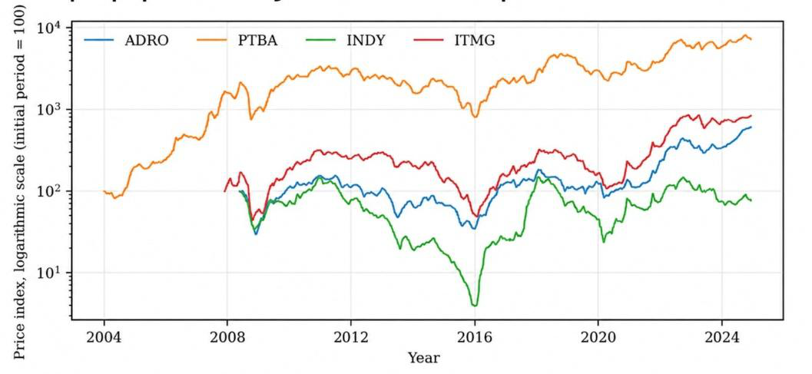
Figure 2. Indexed historical prices of Indonesian coal-sector stocks (base = 100; logarithmic scale)

Stationarity Tests
Stationarity was assessed using the Augmented Dickey-Fuller (ADF) and Kwiatkowski-Phillips-Schmidt-Shin (KPSS) tests. The ADF test evaluates the null hypothesis of a unit root, whereas the KPSS test evaluates the null hypothesis of stationarity. Using both tests reduces reliance on a single testing framework.
Table 5. ADF and KPSS stationarity-test results
Stock | Series | ADF statistic | ADF p-value | ADF result | KPSS statistic | KPSS result
ADRO | Level | 2.3420 | 0.9990 | Non-stationary | 4.9195 | Non-stationary
ADRO | First difference | -11.9144 | <0.001 | Stationary | 0.7560 | Non-stationary
ADRO | Log return | -70.2494 | <0.001 | Stationary | 0.2270 | Stationary
PTBA | Level | -0.4399 | 0.9032 | Non-stationary | 8.0567 | Non-stationary
PTBA | First difference | -13.4552 | <0.001 | Stationary | 0.1009 | Stationary
PTBA | Log return | -12.5069 | <0.001 | Stationary | 0.2371 | Stationary
INDY | Level | -2.2511 | 0.1882 | Non-stationary | 1.6820 | Non-stationary
INDY | First difference | -13.1830 | <0.001 | Stationary | 0.0654 | Stationary
INDY | Log return | -11.1988 | <0.001 | Stationary | 0.1139 | Stationary
ITMG | Level | 0.3017 | 0.9774 | Non-stationary | 5.5611 | Non-stationary
ITMG | First difference | -13.6765 | <0.001 | Stationary | 0.2637 | Stationary
ITMG | Log return | -13.3945 | <0.001 | Stationary | 0.1003 | Stationary
At level, all four price series are non-stationary under both tests. After first-order differencing, the ADF test rejects the unit-root null for every stock. KPSS also supports stationarity for PTBA, INDY, and ITMG, while ADRO produces a conflicting KPSS result; its stationary log-return series and the broader diagnostics nevertheless support first-order integration. Accordingly, d = 1 was retained for all company-specific ARIMA models.

3.1.2. Model Performance During the Testing Period

Comparison of ARIMA, Standalone LSTM, and Hybrid ARIMA-LSTM
The ARIMA output represents the linear price forecast. In the hybrid model, the residual between the observed price and the ARIMA forecast was modeled with an LSTM using the previous 30 residual observations. The final hybrid forecast was obtained by adding the estimated nonlinear residual correction to the ARIMA forecast:
$${\left(P\right)}_{t}^{Hybrid}={\left(P\right)}_{t}^{ARIMA}+{\left(e\right)}_{t}^{LSTM}$$

Forecasts were evaluated out of sample from January 2, 2023 to December 30, 2024. Table 6. provides a like-for-like comparison using MAE, RMSE, and MAPE, which were available for all three models. Because MAE and RMSE depend on the nominal price scale, cross-stock interpretation focuses primarily on MAPE. Within each stock, however, all three metrics can be compared directly.
Table 6. Out-of-sample performance comparison, January 2023-December 2024
Stock | Model | MAE (IDR) | RMSE (IDR) | MAPE (%)
ADRO | ARIMA(3,1,3) | 275.76 | 310.01 | 21.77
 | Standalone LSTM | 344.80 | 404.24 | 24.48
 | Hybrid ARIMA-LSTM | 151.67 | 170.51 | 11.97
PTBA | ARIMA(1,1,3) | 206.46 | 254.46 | 9.61
 | Standalone LSTM | 254.20 | 285.26 | 11.74
 | Hybrid ARIMA-LSTM | 113.55 | 139.95 | 5.29
INDY | ARIMA(1,1,3) | 806.47 | 856.49 | 54.44
 | Standalone LSTM | 70.20 | 91.79 | 4.32
 | Hybrid ARIMA-LSTM | 443.56 | 471.07 | 29.94
ITMG | ARIMA(3,1,3) | 3,015.27 | 3,423.97 | 15.47
 | Standalone LSTM | 4,649.92 | 4,784.36 | 22.40
 | Hybrid ARIMA-LSTM | 1,658.40 | 1,883.18 | 8.51

The hybrid model reduced MAPE relative to ARIMA by approximately 45% for every stock. It also outperformed standalone LSTM for ADRO, PTBA, and ITMG. The exception is INDY: standalone LSTM achieved a MAPE of 4.32%, compared with 29.94% for the hybrid model and 54.44% for ARIMA. Therefore, the evidence does not support a claim that hybridization is universally superior. Instead, the preferred model depends on the characteristics of the individual stock series.
R² was additionally calculated for ARIMA, standalone LSTM, and hybrid ARIMA-LSTM to assess out-of-sample performance relative to the mean-value benchmark. A negative out-of-sample R² indicates that the model produced a larger sum of squared errors than a benchmark that predicts the mean of the observed testing values.
Table 7. Out-of-sample R² comparison of ARIMA, standalone LSTM, and hybrid ARIMA-LSTM
Stock | ARIMA R² | Standalone LSTM R² | Hybrid R²
ADRO | -0.0542 | −0.6223 | 0.6811
PTBA | -0.3226 | −0.5115 | 0.5999
INDY | -7.6967 | 0.8870 | −1.6307
ITMG | -3.3401 | −6.3892 | −0.3129

ADRO and PTBA achieved positive hybrid R² values of 0.6811 and 0.5999, respectively, whereas their standalone LSTM and ARIMA models produced negative R² values. For INDY, standalone LSTM achieved the highest R² of 0.8870, consistent with its substantially lower MAE, RMSE, and MAPE compared with ARIMA and hybrid ARIMA-LSTM. For ITMG, all three models produced negative R² values, although the hybrid model achieved the least negative value (−0.3129) and the lowest percentage error. These results demonstrate that model performance is stock-specific and that percentage-based errors and R² should be interpreted together rather than relying on a single evaluation metric.
Table 8. Mean MAPE from three-fold expanding-window validation across the 2020–2022 pre-test periods
Stock | ARIMA (%) | Standalone LSTM (%) | Hybrid ARIMA-LSTM (%)
ADRO | 24.67 | 6.32 | 24.61
PTBA | 20.77 | 6.91 | 10.87
INDY | 30.93 | 7.31 | 30.46
ITMG | 30.74 | 10.49 | 30.87

The expanding-window validation provides an additional assessment of forecasting robustness across the 2020, 2021, and 2022 pre-test periods. Standalone LSTM achieved the lowest mean MAPE for all four stocks, with values of 6.32% for ADRO, 6.91% for PTBA, 7.31% for INDY, and 10.49% for ITMG. In contrast, the mean MAPE values of ARIMA and hybrid ARIMA-LSTM were relatively similar across the three validation periods. These results indicate that model performance varies across market regimes and that the hybrid model’s stronger performance for ADRO, PTBA, and ITMG during the final 2023–2024 holdout period should not be interpreted as universally stable across time.

Stock-Specific Prediction Patterns
Figure 3. presents the actual and hybrid-predicted monthly prices for all four stocks during 2023-2024. For PTBA, the hybrid prediction generally followed the direction of actual price movements, although several peaks and declines were smoothed. For INDY, predictions remained above actual prices for much of 2024, indicating slow adjustment to a downward level shift.
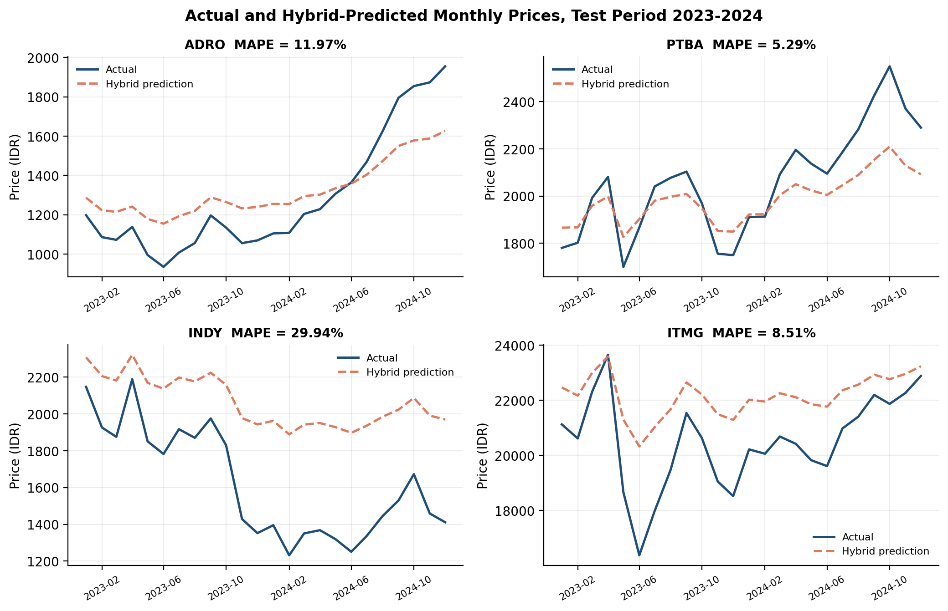
Figure 3. Actual and hybrid-predicted monthly prices for all four stocks during the testing period

3.1.3. Exploratory Projections for 2025-2045 and Dashboard Implementation
- Long-Term Projection Results
The company-specific hybrid ARIMA-LSTM models were extended to generate exploratory monthly projections for ADRO, PTBA, INDY, and ITMG from 2025 to 2045. Although standalone LSTM achieved the best out-of-sample performance for INDY, the hybrid framework was retained for all long-term projections to maintain a consistent projection procedure across the four stocks. These long-horizon values are exploratory scenarios that extrapolate patterns learned from historical adjusted closing prices; they are not investment recommendations. Table 9. reports five-year milestones together with the generated lower and upper uncertainty bounds.
Table 9. Exploratory stock-price projections and uncertainty bounds, 2025-2045
Stock | Year | Projection (IDR) | Lower bound (IDR) | Upper bound (IDR)
ADRO | 2025 | 2,202.67 | 2,033.19 | 2,372.16
ADRO | 2045 | 4,463.10 | 2,889.38 | 6,036.82
PTBA | 2025 | 2,556.53 | 2,358.39 | 2,754.67
PTBA | 2045 | 4,754.61 | 3,065.94 | 6,443.28
INDY | 2025 | 1,634.66 | 1,441.53 | 1,827.80
INDY | 2045 | 3,029.56 | 1,389.25 | 4,669.87
ITMG | 2025 | 25,760.61 | 23,571.01 | 27,950.21
ITMG | 2045 | 53,070.69 | 32,399.12 | 73,742.25

All four central projection paths are higher in 2045 than in 2025, but the trajectories are nonlinear and include periods of decline or limited growth. More importantly, the distance between the lower and upper bounds increases with the horizon. For example, the 2045 range is IDR 1,389.25-4,669.87 for INDY and IDR 32,399.12-73,742.25 for ITMG. The widening bands indicate that point forecasts become progressively less informative over a twenty-year horizon and should not be interpreted as precise future prices.
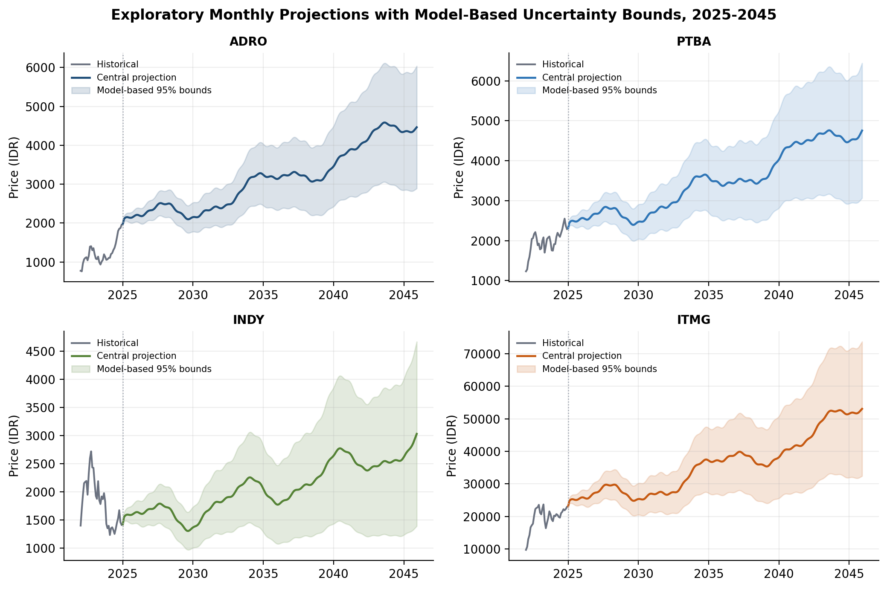
Figure 4. Exploratory monthly projections with ARIMA-based 95% uncertainty bounds for all four stocks, 2025–2045
- Dashboard Implementation
The results were implemented in a web-based analytical dashboard that allows users to select a stock, examine historical prices, compare actual and predicted values during the testing period, inspect evaluation metrics, and explore long-term projections. The dashboard functions as a visualization and analytical interface; it does not constitute a stock-trading or investment-recommendation system. The interface is publicly accessible at https://pkm-forecast-saham-batubara-2025-20-gamma.vercel.app/.

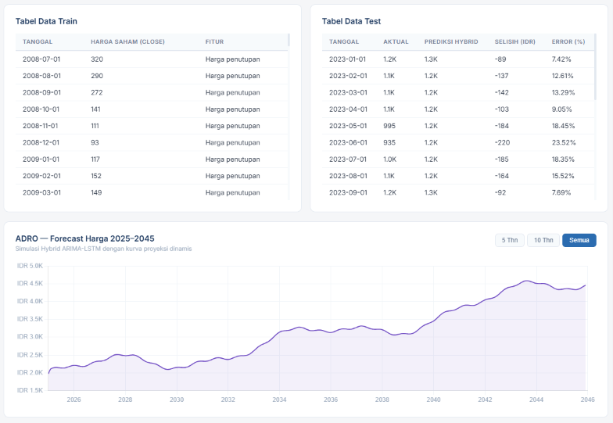 | 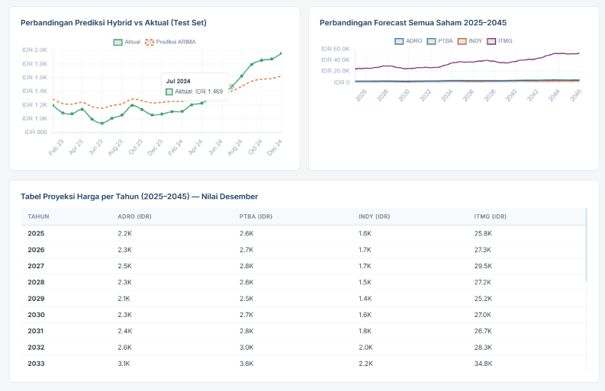

Figure 5. Selected views of the web-based forecasting dashboard

3.2. Discussion
3.2.1. Stock-Specific Value of Hybridization
The results support the value of combining linear and nonlinear components, but only conditionally. Relative to ARIMA, the hybrid model reduced MAE, RMSE, and MAPE for all four stocks. This suggests that the ARIMA residuals contained learnable nonlinear structure. Nevertheless, hybridization did not uniformly outperform an end-to-end standalone LSTM: INDY was modeled far more accurately by standalone LSTM. The central finding is therefore stock-specific rather than universal. A hybrid model is beneficial when the ARIMA component provides a useful linear baseline and the LSTM can learn a stable residual correction; it can be less effective when the linear baseline is severely misspecified for the testing regime [28], [29].

The INDY result illustrates possible error propagation. Its ARIMA model produced a MAPE of 54.44% and R² of -7.6967. Because the hybrid forecast adds an LSTM residual correction to this weak baseline, the correction did not fully offset the large and persistent ARIMA error. In contrast, standalone LSTM learned the price pattern directly and achieved a MAPE of 4.32%. This finding argues for selecting the forecasting architecture separately for each stock after baseline comparison rather than designating Hybrid ARIMA-LSTM as the default model in every case [30].

The expanding-window results further support this interpretation. Although the hybrid model outperformed standalone LSTM for ADRO, PTBA, and ITMG during the 2023–2024 holdout period, standalone LSTM achieved the lowest mean MAPE for all four stocks across the 2020–2022 validation windows. This difference suggests that the relative advantage of hybridization is sensitive not only to stock characteristics but also to the prevailing market regime.

3.2.2. Volatility, Structural Change, and Forecast Errors
Differences in performance are consistent with heterogeneous stock behavior. INDY has the highest return volatility and positive skewness, while its testing-period prices exhibit a downward level shift that the hybrid forecast adjusted to slowly [31]. ADRO and PTBA show stronger hybrid R² values, suggesting that patterns learned from the training period transferred more effectively to the 2023-2024 test regime. ITMG has a relatively low hybrid MAPE but a negative R², reflecting the distinction between moderate percentage error and weak tracking of variation around the testing-period mean.

Financial time series are exposed to regime changes arising from commodity-price cycles, exchange-rate movements, interest rates, regulation, geopolitical events, and firm-specific information. A model based only on past closing prices cannot distinguish these causal drivers. Structural breaks can therefore produce persistent over- or underprediction even when average percentage errors appear acceptable [32].

3.2.3. Comparison with Previous Forecasting Studies
The improvement over ARIMA for all four stocks is consistent with prior hybrid-forecasting studies [33], which report that combining a linear model with a nonlinear learner can capture residual structure missed by either component alone. However, the INDY result qualifies any general claim of hybrid superiority. Unlike studies that report uniform gains from hybridization, the present comparison shows that a standalone LSTM can be preferable when nonlinear dynamics dominate or when the ARIMA baseline performs poorly. This stock-dependent result is the principal empirical contribution of the comparison.

Recent studies also highlight that machine-learning forecasting performance depends on data characteristics, feature selection, and evaluation strategies. Adaptive and hybrid approaches remain relevant for addressing nonlinear financial dynamics and changing market conditions.
3.2.4. Interpretation of the 2025-2045 Projections
The upward central paths should be interpreted as conditional extrapolations rather than forecasts with investment certainty. These projections represent scenarios generated from historical adjusted closing-price patterns and assume that past temporal relationships remain informative beyond the evaluation period. However, long-term financial forecasting is highly exposed to structural changes, including energy transition policies, carbon regulations, changes in coal demand, corporate actions, inflation, and macroeconomic shocks that may not be captured in the training data. Therefore, the increasing uncertainty bounds should be considered an essential component when interpreting long-horizon projection results [34].

Caution is particularly required for INDY and ITMG because their hybrid models produced negative out-of-sample R² values during the holdout evaluation period. Although the projection paths provide methodological scenarios of possible future price movements, they should not be interpreted as precise future prices. When the primary objective is predictive accuracy, the forecasting model should be selected individually for each stock based on out-of-sample performance evaluation rather than assuming that the hybrid ARIMA-LSTM framework is universally superior.

4. CONCLUSION
This study developed and evaluated ARIMA, standalone LSTM, and hybrid ARIMA–LSTM models for forecasting the stock prices of four Indonesian coal-sector companies: ADRO, PTBA, INDY, and ITMG. During the January 2023–December 2024 out-of-sample evaluation period, the hybrid model produced MAPE values of 5.29% for PTBA, 8.51% for ITMG, 11.97% for ADRO, and 29.94% for INDY. The positive out-of-sample R² values obtained for ADRO and PTBA indicate that the hybrid forecasts explained part of the observed price variation. In contrast, the negative R² values for ITMG and INDY indicate that the hybrid model performed worse than the mean-value benchmark in squared-error terms during the testing period.

The comparison with individual models shows that forecasting performance depends on the characteristics of each stock. Hybridization improved ARIMA forecasts but did not consistently outperform standalone LSTM across all companies. Therefore, the use of an LSTM model to correct ARIMA residuals does not guarantee uniform improvements. For predictive applications, the forecasting approach should be selected separately for each stock based on out-of-sample evaluation results.

For the exploratory long-term analysis in this study, however, the company-specific hybrid models were retained consistently across all four stocks to maintain a common projection procedure. These models were used to generate monthly projections for 2025–2045. The projections should be interpreted only as exploratory scenarios based on historical price patterns rather than investment recommendations. The developed dashboard functions as an analytical interface for presenting historical data, model evaluation results, and long-term projection scenarios.

These findings are limited to the four evaluated stocks, historical closing-price inputs, the January 2023–December 2024 final testing period, and the selected three-fold expanding-window validation design. Although the additional validation provides evidence across multiple pre-test periods, future studies should extend the analysis to more rolling-origin windows, incorporate external financial variables in multivariate forecasting frameworks, and apply more comprehensive uncertainty-estimation methods.

ACKNOWLEDGMENT
The authors gratefully acknowledge Universitas Negeri Surabaya and all research-team members for their support in data preparation, model development, and dashboard implementation. This research was funded under the research grant stipulated in Decree No. 1078/UN38/HK/2025.

REFERENCES
[1] N. S. A. Nuri Aslami, “Analisis Kebijakan Perdagangan Internasional,” Journal Economy and Currency Study (JECS), vol. 4, no. 1, pp. 14–23, Jan. 2022, doi: 10.51178/jecs.v4i1.358.
[2] J. Novia, “RELATIONSHIP BETWEEN PALM OIL AND COAL PRICES ON THE GROWTH OF THE TRADE BALANCE IN 2009 - 2020,” Jun. 20, 2022. doi: 10.31219/osf.io/6db7q.
[3] D. Nuryadin, I. B. P. C. P. Sarayuda, and D. Q. Nada, “Forecasting the Stock Price of Coal and Coal Commodity Companies using the ARIMA and ARCH/GARCH Models for 2011-2022,” Jurnal Samudra Ekonomi dan Bisnis, vol. 16, no. 1, pp. 29–45, Jan. 2025, doi: 10.33059/jseb.v16i1.10797.
[4] L. Mochurad and A. Dereviannyi, “An ensemble approach integrating LSTM and ARIMA models for enhanced financial market predictions,” R. Soc. Open Sci., vol. 11, no. 9, Sep. 2024, doi: 10.1098/rsos.240699.
[5] Dr. G. Singh, “Machine Learning Models in Stock Market Prediction,” International Journal of Innovative Technology and Exploring Engineering, vol. 11, no. 3, pp. 18–28, Jan. 2022, doi: 10.35940/ijitee.C9733.0111322.
[6] S. A. Amellia Kharis, A. H. Anna Zili, M. Malik, W. Nuryaningrum, and A. Putri, “Comparing machine learning models for Indonesia stock market prediction,” Indonesian Journal of Electrical Engineering and Computer Science, vol. 38, no. 1, p. 508, Apr. 2025, doi: 10.11591/ijeecs.v38.i1.pp508-516.
[7] L. Slater et al., “Hybrid forecasting: using statistics and machine learning to integrate predictions from dynamical models,” Sep. 20, 2022. doi: 10.5194/hess-2022-334.
[8] S. Saleti, L. Y. Panchumarthi, Y. R. Kallam, L. Parchuri, and S. Jitte, “Enhancing Forecasting Accuracy with a Moving Average-Integrated Hybrid ARIMA-LSTM Model,” SN Comput. Sci., vol. 5, no. 6, p. 704, Jul. 2024, doi: 10.1007/s42979-024-03060-4.
[9] M. M. Kumbure, C. Lohrmann, P. Luukka, and J. Porras, “Machine learning techniques and data for stock market forecasting: A literature review,” Expert Syst. Appl., vol. 197, p. 116659, Jul. 2022, doi: 10.1016/j.eswa.2022.116659.
[10] I. K. Nti, A. F. Adekoya, and B. A. Weyori, “A systematic review of fundamental and technical analysis of stock market predictions,” Artif. Intell. Rev., vol. 53, no. 4, pp. 3007–3057, Apr. 2020, doi: 10.1007/s10462-019-09754-z.
[11] O. Bustos, A. Pomares-Quimbaya, and R. Stellian, “Machine learning, stock market forecasting, and market efficiency: a comparative study,” Int. J. Data Sci. Anal., vol. 20, no. 7, pp. 6815–6839, Nov. 2025, doi: 10.1007/s41060-025-00854-4.
[12] G. E. P. Box and G. M. Jenkins, “Some Recent Advances in Forecasting and Control,” Appl. Stat., vol. 17, no. 2, p. 91, 1968, doi: 10.2307/2985674.
[13] G. P. Zhang, “Time series forecasting using a hybrid ARIMA and neural network model,” Neurocomputing, vol. 50, pp. 159–175, Jan. 2003, doi: 10.1016/S0925-2312(01)00702-0.
[14] D. Chicco, M. J. Warrens, and G. Jurman, “The coefficient of determination R-squared is more informative than SMAPE, MAE, MAPE, MSE and RMSE in regression analysis evaluation,” PeerJ Comput. Sci., vol. 7, p. e623, Jul. 2021, doi: 10.7717/peerj-cs.623.
[15] A. Nabil, S. Barakat, A. Aboelfetouh, and S. Elhishi, “Integrating macroeconomic and technical indicators into forecasting the stock market: a hybrid approach for efficient feature selection,” Sci. Rep., vol. 16, no. 1, p. 27553, Sep. 2026, doi: 10.1038/s41598-026-67696-3.
[16] F. Li and Z. Chen, “Dynamic quantification anti-fraud machine learning model for real-time transaction fraud detection in banking,” Discover Computing, vol. 28, no. 1, p. 59, May 2025, doi: 10.1007/s10791-025-09549-7.
[17] H. N. Bhandari, B. Rimal, N. R. Pokhrel, R. Rimal, K. R. Dahal, and R. K. C. Khatri, “Predicting stock market index using LSTM,” Machine Learning with Applications, vol. 9, p. 100320, Sep. 2022, doi: 10.1016/j.mlwa.2022.100320.
[18] K. Kashif and R. Ślepaczuk, “LSTM-ARIMA as a hybrid approach in algorithmic investment strategies,” Knowl. Based. Syst., vol. 320, p. 113563, Jun. 2025, doi: 10.1016/j.knosys.2025.113563.
[19] A. Apicella, F. Isgrò, and R. Prevete, “Don’t push the button! Exploring data leakage risks in machine learning and transfer learning,” Artif. Intell. Rev., vol. 58, no. 11, p. 339, Aug. 2025, doi: 10.1007/s10462-025-11326-3.
[20] Z. Zhan and S.-K. Kim, “Versatile time-window sliding machine learning techniques for stock market forecasting,” Artif. Intell. Rev., vol. 57, no. 8, p. 209, Jul. 2024, doi: 10.1007/s10462-024-10851-x.
[21] E. Yao, L. Zhang, X. Li, and X. Yun, “Traffic Forecasting of Back Servers Based on ARIMA-LSTM-CF Hybrid Model,” International Journal of Computational Intelligence Systems, vol. 16, no. 1, p. 65, Apr. 2023, doi: 10.1007/s44196-023-00232-7.
[22] D. Fan, H. Sun, J. Yao, K. Zhang, X. Yan, and Z. Sun, “Well production forecasting based on ARIMA-LSTM model considering manual operations,” Energy, vol. 220, p. 119708, Apr. 2021, doi: 10.1016/j.energy.2020.119708.
[23] S. Hochreiter and J. Schmidhuber, “Long Short-Term Memory,” Neural Comput., vol. 9, no. 8, pp. 1735–1780, Nov. 1997, doi: 10.1162/neco.1997.9.8.1735.
[24] A. Q. Md et al., “Novel optimization approach for stock price forecasting using multi-layered sequential LSTM,” Appl. Soft Comput., vol. 134, p. 109830, Feb. 2023, doi: 10.1016/j.asoc.2022.109830.
[25] F. Guo, P. Wang, K. Tansey, Y. Sun, M. Li, and J. Zhou, “Pixel-based agricultural drought forecasting based on deep learning approach: Considering the linear trend and residual feature of vegetation temperature condition index,” Comput. Electron. Agric., vol. 237, p. 110570, Oct. 2025, doi: 10.1016/j.compag.2025.110570.
[26] S. Sibiya, S. Ramroop, S. F. Melesse, and N. B. Mbatha, “Development of a Hybrid SG-ARIMA-LSTM Model for Improved Meteorological Drought Forecasting Using the Standardized Precipitation Index in the KwaZulu-Natal Province, South Africa,” J. Hydrometeorol., vol. 27, no. 5, pp. 651–679, May 2026, doi: 10.1175/JHM-D-25-0111.1.
[27] F. A. N. Perez, F. J. A. Mosqueda, A. R. Cuevas, J. M. Beltran, and J. C. N. Perez, “Leakage-Controlled Horizon-Specific Model Selection for Daily Equity Forecasting: An Automated Multi-Model Pipeline,” Forecasting, vol. 8, no. 2, p. 34, Apr. 2026, doi: 10.3390/forecast8020034.
[28] F. Saâdaoui and H. Rabbouch, “Financial forecasting improvement with LSTM-ARFIMA hybrid models and non-Gaussian distributions,” Technol. Forecast. Soc. Change, vol. 206, p. 123539, Sep. 2024, doi: 10.1016/j.techfore.2024.123539.
[29] J. Zhang, H. Liu, W. Bai, and X. Li, “A hybrid approach of wavelet transform, ARIMA and LSTM model for the share price index futures forecasting,” The North American Journal of Economics and Finance, vol. 69, p. 102022, Jan. 2024, doi: 10.1016/j.najef.2023.102022.
[30] X. Wang, R. J. Hyndman, F. Li, and Y. Kang, “Forecast combinations: An over 50-year review,” Int. J. Forecast., vol. 39, no. 4, pp. 1518–1547, Oct. 2023, doi: 10.1016/j.ijforecast.2022.11.005.
[31] A. Opschoor and A. Lucas, “Time-varying variance and skewness in realized volatility measures,” Int. J. Forecast., vol. 39, no. 2, pp. 827–840, Apr. 2023, doi: 10.1016/j.ijforecast.2022.02.009.
[32] J. M. Pinto and J. L. Castle, “Machine Learning Dynamic Switching Approach to Forecasting in the Presence of Structural Breaks,” Journal of Business Cycle Research, vol. 18, no. 2, pp. 129–157, Jul. 2022, doi: 10.1007/s41549-022-00066-w.
[33] A. Ampountolas, “Comparative Analysis of Machine Learning, Hybrid, and Deep Learning Forecasting Models: Evidence from European Financial Markets and Bitcoins,” Forecasting, vol. 5, no. 2, pp. 472–486, Jun. 2023, doi: 10.3390/forecast5020026.
[34] M. Paza Mboya and P. Sibbertsen, “Optimal forecasts in the presence of discrete structural breaks under long memory,” J. Forecast., vol. 42, no. 7, pp. 1889–1908, Nov. 2023, doi: 10.1002/for.2988.

